Starting Money: $1000

Basic Concept of the Game:

There are a certain number of CEOs and non-CEO players. The CEOs are tasked with creating a vague game idea and pitching it to the players. The CEOs can use their money to invest in various parts of the game to increase things like, profit, or probability of selling the game. The CEOs choose a certain number of numbers (corresponding to the amount they spent on production, see second table). The players then choose a game to invest in are given a certain dice, determining by the amount of money spent on advertising, and roll a number of times determined by the amount of money spent on advertising. The more times the non-CEO player’s roll matches the CEO’s number, the more money the CEO makes. The game can go on for one, or several rounds.

Basic Ideas:

|  |  |
| --- | --- |
| Players | CEOS |
| 2 | 1 |
| 3 | 1 |
| 4 | 2 |
| 5 | 2 |
| 6 | 2 |
| 7 | 3 |
| 8 | 3 |

Money spent on dev = unit price/profit and time used for development

Money spent on adv = guaranteed profit and dice players use are more likely to match yours

Money spent on production = number of numbers given that make you money

Dev time = amount of time given to think of a game idea, the idea can be rough or vague, but it should we have taken into account when choosing the non-CEO players choose a game

Dice: d15, d12,d10,d8,d4,d3

Non CEO players gain points for successful rolls, each player gains half a point for another player’s successful role.

Non CEO players roll choose a game to invest in and roll 3 times as a base

non CEO players will not know what the other players are choosing

|  |  |
| --- | --- |
| Money spent on production | Amount of Chosen numbers (caps at 5) |
| 0 | 2 |
| 275 | 3 |
| 525 | 4 |
| 725 | 5 |
|  |  |
|  |  |
|  |  |

Non ceo player chooses your game = +$200 money

For each $100 spent on adv, +75 guaranteed profit, $250 spent on adv, +1 dice role

For each $200 spent on dev, +150 for price and 1.5 min for dev time

Initial price per unit = $100

Each round price per unit = old price per unit + $100

|  |  |
| --- | --- |
| Money spent on adv | Type of Dice |
| 0 | D15 |
| 100 | D12 |
| 200 | D10 |
| 300 | D8 |
| 450 | D6 |
| 550 | D4 |
| 750 | D3 |

Left over money can be spent on later projects

Answers:

Q: What are the elements of change? Give an example and explain the probability of the event occuring.

A: The number of ways to sell a product changes as the amount of possible numbers increases. For example, if you spent 525 dollars on production and 450 on advertising, players who rolled, trying to buy your game, the player would have a 4/6 probability of rolling one of your chosen numbers.

Q: Are there dependent and independent choices involved in your game?

A: Yes, an example of a dependent choice in my game would be the money spent on advertising, development, and production, if you spend a certain amount of money on one section you cannot spend that on another

*Play through example:*  
 4 Players, 1 round game

2 CEOs, each invents separate games on pitches them to the players,

CEO 1 invests $525 in production, $200 in dev, and $100 in adv.

CEO 2 invests $275 in production, $400 in dev, and $100 in adv.

CEO 1 chooses 1, 3, and 6 as his numbers

CEO 2 chooses 3, 5, and 7 as his numbers

Both non ceo players prefer CEO 2’s idea, and roll

The non ceo players role three d12s:

player 1 gets a 1, 4, and 6

player 2 gets a 2, 7, 8

CEO sells $800 in units

There was a ½ chance that each CEO would get chosen, but because CEO 1 spent more time creating a compelling idea, he got more non ceo players to choose his games. However, because he only spent $100 on advertising, he only had a ¼ chance of making money from any given non ceo player role

*Show at least one game element that you have designed. This Could be an example of a playing board, sample cards from the game, a score sheet, or another item that you get approved by the instructor:*

|  |  |  |  |  |  |
| --- | --- | --- | --- | --- | --- |
|  | Money | $Gained | $ADV | $DEV | $Prod. |
| Round1 |  |  |  |  |  |
| Round2 |  |  |  |  |  |
| Round3 |  |  |  |  |  |
| Round4 |  |  |  |  |  |
| Round5 |  |  |  |  |  |
| Round6 |  |  |  |  |  |
| Round7 |  |  |  |  |  |
| Round8 |  |  |  |  |  |
| Round9 |  |  |  |  |  |
| Round10 |  |  |  |  |  |

Dice:

D15:

D12:

D10:

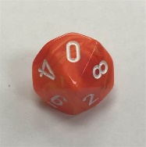

D8:

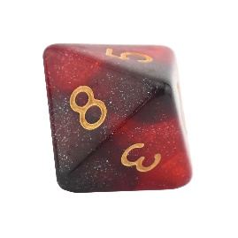

D4:

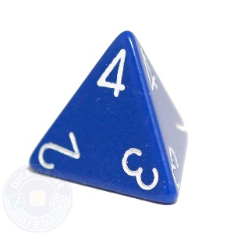

D3:

